Educational cum Industrial Visit to Dabur India Ltd., Sahibabad
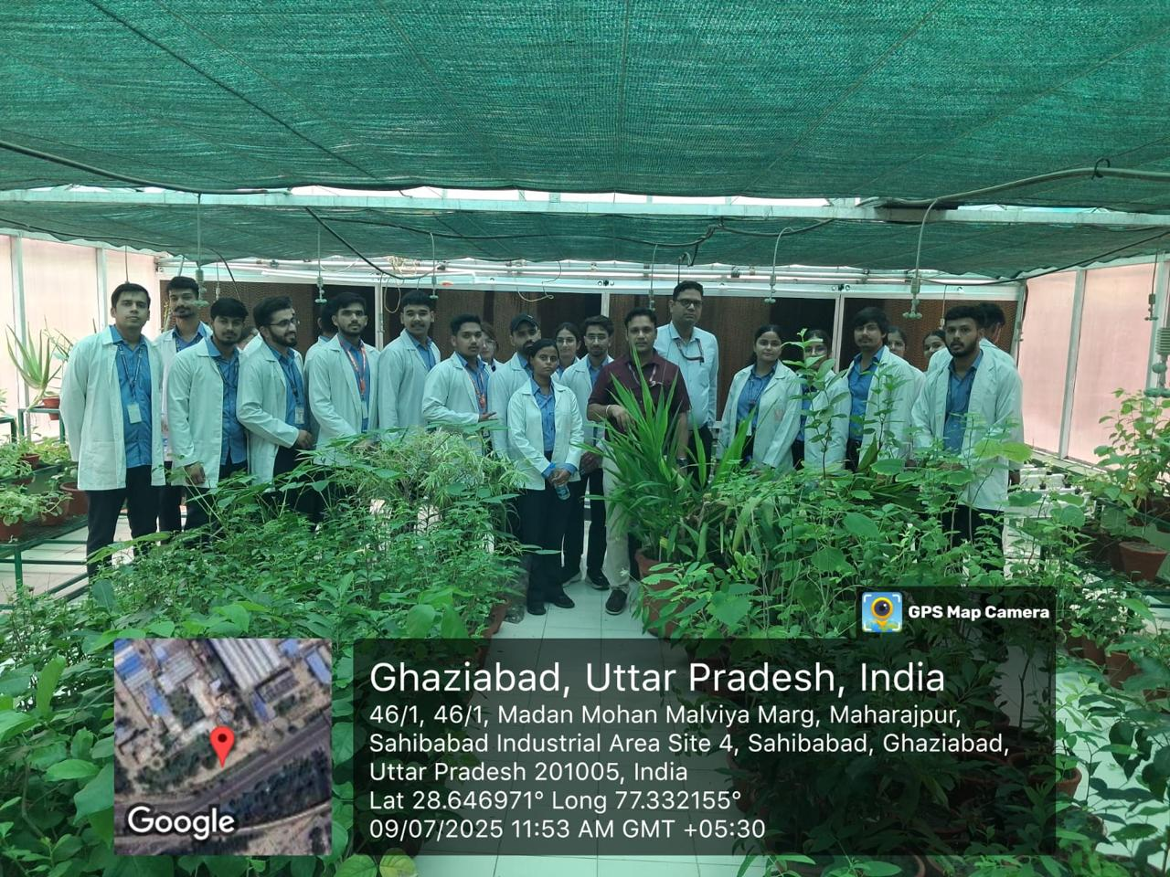
An Educational cum Industrial Visit was organized by the Faculty of Ayurveda, Shri Baba Mastnath Ayurvedic College, Rohtak, under the aegis of Baba Mastnath University (BMU), after obtaining due approval from the Internal Quality Assurance Cell (IQAC).
The visit was conducted on 09 July 2025 for the students of BAMS 2nd Professional (Batch 2022–23) with the primary objective of providing practical exposure to industrial processing, quality control, and large-scale manufacturing of Ayurvedic products.
During the visit, students were given an overview of Dabur India Ltd., one of the leading Ayurvedic and FMCG companies in India. The experts at the facility explained the manufacturing processes of various classical and proprietary Ayurvedic formulations, including raw material procurement, authentication, processing, packaging, and storage.
The students were also introduced to modern quality control techniques and Good Manufacturing Practices (GMP) followed in the industry to ensure safety, efficacy, and standardization of Ayurvedic medicines. Special emphasis was laid on maintaining hygiene, automation in production, and adherence to regulatory guidelines.
A guided tour of the herbal garden and plant sections was also arranged, where students observed various medicinal plants and understood their practical utility in drug formulation.
The visit proved to be highly informative and enriching, bridging the gap between theoretical knowledge and industrial application. It enhanced students’ understanding of pharmaceutical standards, industrial workflow, and career opportunities in the Ayurvedic manufacturing sector.
The visit was successfully coordinated under the guidance of faculty members, including Dr. Austluxmi, Dr. Rakesh, Dr. Nitin and Dr. Amrit , who accompanied the students throughout the program.

